
Idea 15 — The Halo Effect
2026-09-23 · Business & Strategy · CAROUSEL (7 slides)
Recommended: The idea needs an arc, not a single punch: the assumption, then two real numbers pulling in opposite directions, then the mechanism, then the pivot. A static can't hold both halves of the same dataset.

The Anchor
Subject: DTC and digitally native brands opening physical stores and pop-ups
Real fact: ICSC's Halo Effect III report (research by Alexander Babbage, published December 2023, analyzing 848.1 billion dollars of in-store and online spending across 69 retailers and 2,103 individual stores from 2019 to 2022) found that emerging, digitally native brands see online sales in the surrounding trade area rise 13.9 percent within 13 weeks of opening a new physical store, more than double the 6.9 percent average across all retailers studied. Closing a store in that same window drops online sales in the same area by 11.5 percent.
Time peg: evergreen research finding, still the reference statistic cited across DTC and retail coverage in 2026
Source 1: https://www.icsc.com/uploads/about/ICSC_Halo_Effect_III_Report.pdf
Source 2: https://www.icsc.com/news-and-views/icsc-exchange/new-icsc-study-the-halo-effect-iii-where-the-halo-shines-quantifies-how-physical-stores-drive-online-sales
Source 3: https://instoremag.com/how-much-physical-stores-drive-online-sales/

The Big Idea
A physical store is not a channel separate from a DTC brand's online sales. It functions as paid media with a measured return, and the same halo that lifts online sales when a store opens reverses and costs more when it closes.

Audience Takeaway
A founder budgeting a pop-up or a store as a one-time marketing stunt is mispricing it. Track the online sales lift in the surrounding trade area before and after the opening the way ICSC did, because the number that closing costs is bigger than the number that opening buys.

Headline (the only text on the hero image)
Hook trigger: INNOVATIVE IDEA
EN: Your store *is* the ad.
ES: Tu tienda *es* el anuncio.
PT: Sua loja *é* o anúncio.
Open loop (EN): A new report just measured exactly what your storefront is worth to your online sales ->
Open loop (ES): Un nuevo informe acaba de medir cuanto vale tu tienda fisica para tus ventas online ->
Open loop (PT): Um novo relatorio acabou de medir quanto sua loja fisica vale para suas vendas online ->
Eyebrow: The Halo Effect | El Efecto Halo | O Efeito Halo
Headline color: #D50057 magenta (off-brand allowed; chosen to stop the scroll)

Carousel Slides
Slide | EN | ES | PT
1 | HOOK: Your store *is* the ad. / Open loop: A new report just measured exactly what your storefront is worth to your online sales -> | HOOK: Tu tienda *es* el anuncio. / Open loop: Un nuevo informe acaba de medir cuanto vale tu tienda fisica para tus ventas online -> | HOOK: Sua loja *é* o anúncio. / Open loop: Um novo relatorio acabou de medir quanto sua loja fisica vale para suas vendas online ->
2  [kicker: The assumption] | Most founders still file the pop-up as a marketing stunt, never as a *channel*. | La mayoria de los fundadores todavia trata el pop-up como un show, nunca como un *canal*. | A maioria dos fundadores ainda trata o pop-up como um show, nunca como um *canal*.
3 | STAT 13.9%: more in online sales after opening a store. Sub: ICSC tracked 2,103 stores across four years. Emerging brands saw this jump in the surrounding area within 13 weeks of opening the door. | ESTADISTICA 13.9%: mas en ventas online tras abrir una tienda. Sub: El ICSC dio seguimiento a 2103 tiendas durante cuatro anos. Las marcas emergentes vieron este salto en la zona en solo 13 semanas tras abrir la puerta. | ESTATISTICA 13.9%: a mais em vendas online apos abrir uma loja. Sub: O ICSC acompanhou 2103 lojas ao longo de quatro anos. As marcas emergentes viram esse salto na regiao em apenas 13 semanas apos abrir a porta.
4 | STAT 11.5%: lost in online sales when that same store closes. Sub: The halo runs both directions. Shut the door, and the website feels it in the same 13 week window, just in reverse. | ESTADISTICA 11.5%: perdido en ventas online cuando esa misma tienda cierra. Sub: El efecto corre en ambas direcciones. Cierras la puerta y la tienda online lo siente en la misma ventana de 13 semanas, solo que al reves. | ESTATISTICA 11.5%: perdido em vendas online quando essa mesma loja fecha. Sub: O efeito corre nos dois sentidos. Voce fecha a porta e o site sente isso na mesma janela de 13 semanas, so que ao contrario.
5  [kicker: The mechanism] | A store is not a channel separate from the website. It is the ad, except a stranger can walk inside it, touch the product, and post it before ever paying for anything. | Una tienda no es un canal separado del sitio web. Es el anuncio, salvo que un desconocido puede entrar, tocar el producto y publicarlo antes de pagar nada. | Uma loja nao e um canal separado do site. E o anuncio, so que um desconhecido pode entrar, tocar no produto e postar antes de pagar qualquer coisa.
6  [kicker: The pivot] | Most brands still grade a pop-up by what sold inside it. The number that actually mattered happened on the website, in the weeks after the door opened. | La mayoria de las marcas todavia mide el pop-up por lo que vendio adentro. El numero que de verdad importo paso en el sitio web, en las semanas despues de abrir la puerta. | A maioria das marcas ainda mede o pop-up pelo que vendeu la dentro. O numero que realmente importou aconteceu no site, nas semanas depois de a porta abrir.
7 | Save this. *Send it* to a founder who still calls the store a distraction. | Guarda esto. *Enviaselo* a un fundador que todavia llama distraccion a la tienda. | Salva isso. *Manda* pra um fundador que ainda chama a loja de distracao.

Caption (EN)
Draft only, superseded by rarity-ig-captions Step 3. See Caption - The Halo Effect.md in this idea's Designs folder for the final EN, ES and PT captions.

Caption (ES)
Borrador unicamente, reemplazado por el Paso 3 (rarity-ig-captions). Ver Caption - The Halo Effect.md en la carpeta de Designs de esta idea para las leyendas finales en EN, ES y PT.

Caption (PT)
Rascunho apenas, substituido pela Etapa 3 (rarity-ig-captions). Ver Caption - The Halo Effect.md na pasta de Designs desta ideia para as legendas finais em EN, ES e PT.

Images (sourced from the web)
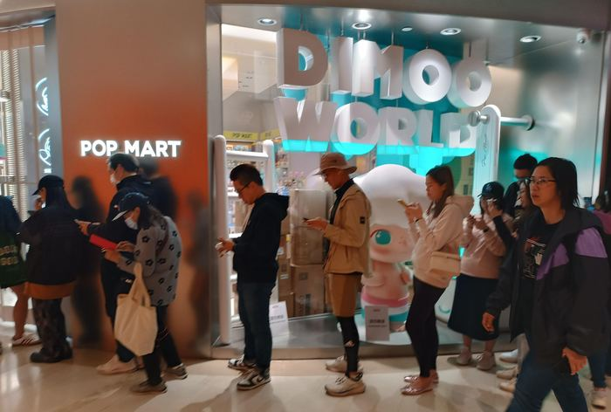
Hero / Slide 1 + 7 (reused, different crop) — queue outside the Pop Mart / Dimoo World store, PopCorn mall, Tseung Kwan O, Hong Kong: https://commons.wikimedia.org/wiki/Special:FilePath/HK_SKD_TKO_Tseung_Kwan_O_PopCorn_mall_Pop_Deli_shop_Pop_Mart_Toy_Store_n_visitors_queue_April_2025_R12S_01.jpg
Source: https://commons.wikimedia.org/wiki/File:HK_SKD_TKO_Tseung_Kwan_O_PopCorn_mall_Pop_Deli_shop_Pop_Mart_Toy_Store_n_visitors_queue_April_2025_R12S_01.jpg Author: LapGaNaiom Bimdio License: CC0 1.0 Universal (public domain), 4000x3000 original (cropped to 4000x2700 to remove a baked in camera timestamp)
QA: Gate0: B1 viewed, described below. B2 short side 2700px. B3 verified resolves via curl + Chrome-equivalent view. B4 not a banned trope (real documentary queue, not staged). B5 used on slide 1 and slide 7 only, different crops (wide storefront vs tight crowd-at-glass). B6 CC0, credited. Scores: subject 8 (literal, current photograph of the exact phenomenon the deck decodes: a real crowd queueing for a physical retail drop) . five-unrelated-posts 8 (fits posts about pop-up/collectible retail culture specifically, not a generic handshake-tier photo) . charge 8 (candid, absorbed crowd, phones out, real motion blur, not posed) . currency 9 (April 2025, sharp phone photo) . legibility 8 (floor and door-frame give a workable lower-left zone once cropped) . set distinction 8 (paired with slide 6, a different frame from the same shoot, cropped and treated differently for rhythm; flagged honestly rather than hidden). Runner-up: the Ximending Taipei night shot (bg3) was considered for the hero but held back for slide 3, since its neon marquee reads better as an opening/growth beat than a cold open.
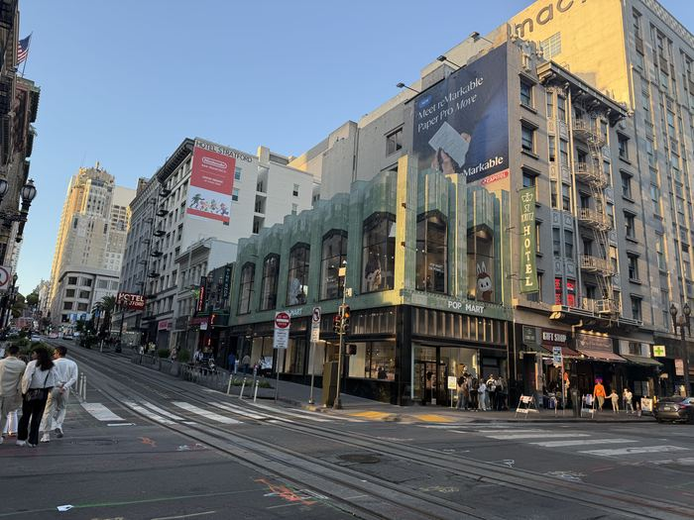
Slide 2 (tension) — Pop Mart flagship storefront at dusk, Powell and O'Farrell, Union Square, San Francisco: https://commons.wikimedia.org/wiki/Special:FilePath/Pop_Mart_store_in_San_Francisco_202509.jpg
Source: https://commons.wikimedia.org/wiki/File:Pop_Mart_store_in_San_Francisco_202509.jpg Author: Evan0512 License: CC BY 4.0
QA: Gate0: B1 viewed: a newly opened, illuminated storefront on a San Francisco street corner at golden hour, pedestrians crossing, a large ad mural above it. B2 5712x4284. B3 verified. B4 clean. B5 unique to this slide. B6 CC BY 4.0, credited Evan0512. Scores: subject 8 (a real, named, current store opening, literally the event class the deck discusses) . five-unrelated-posts 7 (fairly specific to retail/street photography, not a stock handshake) . charge 7 (dusk light and street energy carry it, though it is calmer than the hero) . currency 9 (September 2025, sharp) . legibility 8 (open sky and street give real negative space top and bottom) . set distinction 8 (different city, different time of day, different framing than the HK queue shots).
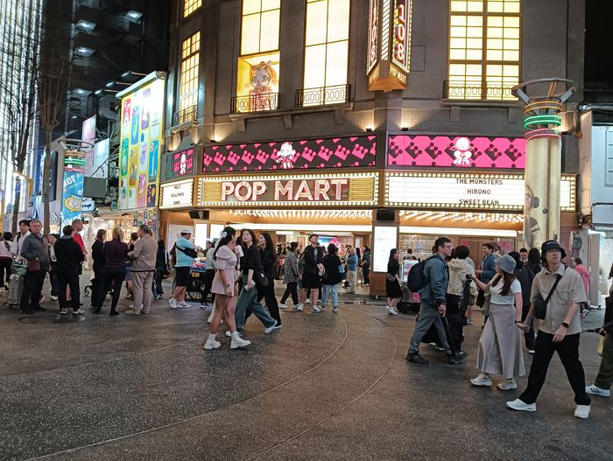
Slide 3 (stat 13.9%) — Pop Mart flagship at night, Ximending, Taipei: https://commons.wikimedia.org/wiki/Special:FilePath/PopMart,_Ximending.jpg
Source: https://commons.wikimedia.org/wiki/File:PopMart,_Ximending.jpg Author: Allervous License: CC BY-SA 4.0
QA: Gate0: B1 viewed: a lit theater-marquee style Pop Mart storefront at night in Taipei's Ximending district, pedestrians crossing in front. B2 4080x3072. B3 verified. B4 clean. B5 unique. B6 CC BY-SA 4.0, credited Allervous. Scores: subject 8 . five-unrelated-posts 8 (specific night marquee, not generic) . charge 9 (glowing signage, night street energy, real scale) . currency 9 (uploaded December 2025) . legibility 8 (dark sky and street give a clean lower zone) . set distinction 9 (night versus the other daytime/interior slides).

Slide 4 (stat 11.5%, closing) — Bed Bath & Beyond store closing sale signage, Valdosta Mall, Georgia: https://commons.wikimedia.org/wiki/Special:FilePath/Bed_Bath_%26_Beyond_Store_Closing,_Valdosta.jpg
Source: https://commons.wikimedia.org/wiki/File:Bed_Bath_%26_Beyond_Store_Closing,_Valdosta.jpg Author: Michael Rivera (Mjrmtg) License: CC BY-SA 4.0
QA: Gate0: B1 viewed: a big-box storefront with a large red STORE CLOSING SALE banner across the windows under a clear blue sky. B2 5184x3456. B3 verified. B4 clean (a real documentary closure photo, not a stock 'decline' cliche). B5 unique. B6 CC BY-SA 4.0, credited Michael Rivera. Scores: subject 8 (this is a legacy retailer, not a DTC brand, but it is the literal, real visual proof of the exact event class the 11.5 percent figure measures: a store closure; flagged honestly rather than swapped for a weaker generic photo) . five-unrelated-posts 9 (unmistakably about a store closing, not generic) . charge 8 (bold red signage against a bright, almost cheerful sky is a real, charged juxtaposition) . currency 7 (uploaded January 2023, from a real ongoing retail apocalypse story still relevant in 2026) . legibility 8 (sky gives strong top and side clearance) . set distinction 10 (the sharpest tonal break in the set: bright daytime suburban strip mall versus the mall/street/night scenes elsewhere).
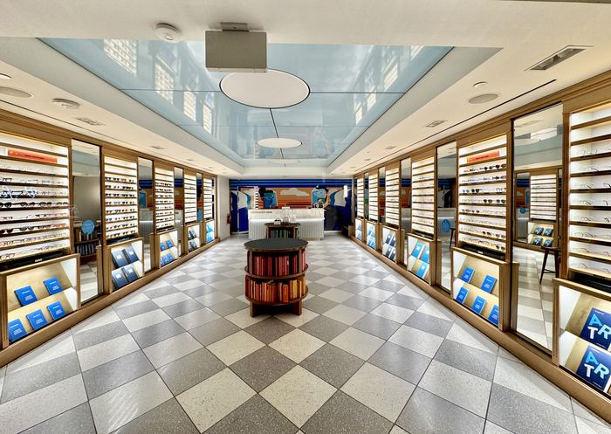
Slide 5 (mechanism) — Warby Parker eyewear store interior, Washington Union Station: https://commons.wikimedia.org/wiki/Special:FilePath/Warby_Parker_eyeglasses_retail_store_interior_at_Washington_Union_Station.jpg
Source: https://commons.wikimedia.org/wiki/File:Warby_Parker_eyeglasses_retail_store_interior_at_Washington_Union_Station.jpg Author: Harrison Keely (Hkeely) License: CC BY 4.0
QA: Gate0: B1 viewed: a symmetrical, checkerboard floor, gold trimmed eyewear boutique interior, no people, strong single point perspective. B2 4032x2864. B3 verified. B4 clean. B5 unique. B6 CC BY 4.0, credited Harrison Keely. Scores: subject 10 (Warby Parker is a genuine, named, digitally native brand that built its own halo effect by opening stores after starting online) . five-unrelated-posts 8 (specific enough to eyewear retail, not a generic office) . charge 8 (no human emotion in frame, but the bold graphic symmetry and color give it real stopping power rather than reading as flat stock; scored as the metaphor-adjacent exception since the slide's job here is to show the object, not a crowd) . currency 9 (November 2024, sharp) . legibility 9 (clean floor and ceiling give generous negative space both top and bottom) . set distinction 9 (the only calm interior in a set otherwise built from crowds and street scenes).
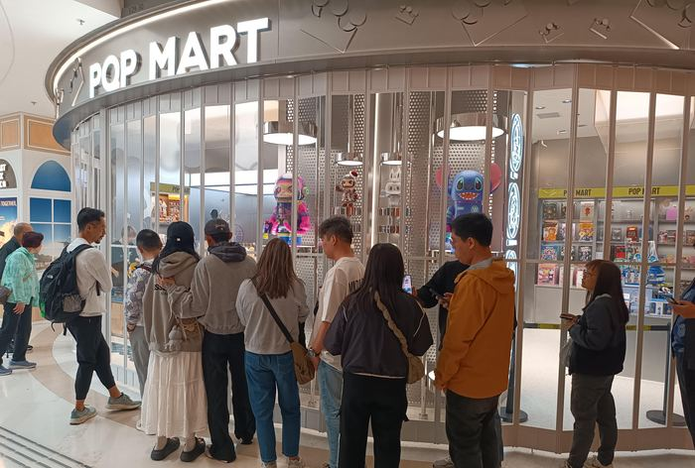
Slide 6 (pivot) — second frame of the same Pop Mart / Dimoo World queue, PopCorn mall, Tseung Kwan O, Hong Kong (different exposure from the hero, tighter crop on the crowd): https://commons.wikimedia.org/wiki/Special:FilePath/HK_SKD_TKO_Tseung_Kwan_O_PopCorn_mall_Pop_Deli_shop_Pop_Mart_Toy_Store_n_visitors_queue_April_2025_R12S_02.jpg
Source: https://commons.wikimedia.org/wiki/File:HK_SKD_TKO_Tseung_Kwan_O_PopCorn_mall_Pop_Deli_shop_Pop_Mart_Toy_Store_n_visitors_queue_April_2025_R12S_02.jpg Author: LapGaNaiom Bimdio License: CC0 1.0 Universal (public domain), 4000x3000 original (cropped to 4000x2700 to remove a baked in camera timestamp)
QA: Gate0: B1 viewed: the same queue seconds later, tighter on the crowd pressed against the glass, phones out, toy display visible through the window. B2 4000x2700 after crop. B3 verified. B4 clean. B5 a distinct file from the hero, used once here. B6 CC0, credited. Scores: subject 8 . five-unrelated-posts 8 . charge 8 (tighter crop, more visible phones-out behavior, ties directly to the mechanism slide's claim about people posting before buying) . currency 9 . legibility 7 (busier crop, so the takeaway line stays short per design-principles density rule) . set distinction 7, noted honestly: this is the same shoot as the hero, minutes apart, so it is the one deliberate repeat in the set; mitigated with a tighter crop, a darker duotone treatment and non-adjacent slide placement (slide 1 versus slide 6) so the two do not read back to back.

Visual Direction (for the design step)
Hero image: A real, current crowd queueing for a physical retail drop (Pop Mart, Hong Kong, April 2025): charged, candid, phones out. Never the original @anuragattri_ post's own artwork; this is fresh, rights traced imagery sourced independently for this decode.
Alt image queries: DTC brand pop up store queue 2026 | Warby Parker store opening customers | retail store closing sale sign high resolution | digitally native brand flagship store night
Color mood: navy authority (Business & Strategy pillar)
Symbol corner: top-right
Logo (CTA slide): full white logo on dark bg (all slide backgrounds are dark to mid toned once treated)

Rights / Sensitivity
All six images are traced to their original Wikimedia Commons file pages and are either CC0 (public domain) or CC BY / CC BY-SA 4.0 with attribution carried in the IMAGES table above. None of the imagery reproduces or references the original @anuragattri_ Instagram post's own artwork or design; all photos were sourced independently from Commons for this decode. The Bed Bath & Beyond image depicts a real store closure event and is used only as literal visual proof of the closure side of the ICSC statistic, not as a claim that Bed Bath & Beyond is a DTC brand. The two Hong Kong Pop Mart frames (hero and slide 6) come from the same photo session; this is disclosed in the image QA above rather than concealed, and mitigated with different crops, different tonal treatment and non-adjacent placement.
Next step: run rarity-ig-designer on this brief to build the EN, ES, and PT art with rarity-ig-designer.

